CHAPTER 1

Ethernet Technologies

1.1 Background

The term Ethernet refers to the family of local-area network (LAN) products covered by the IEEE 802.3 standard that defines what is commonly known as the CSMA/CD protocol. Three data rates are currently defined for operation over optical fiber and twisted-pair cables:
• 10 Mbps—10Base-T Ethernet
• 100 Mbps—Fast Ethernet
• 1000 Mbps—Gigabit Ethernet
10-Gigabit Ethernet is under development and will likely be published as the IEEE 802.3ae supplement to the IEEE 802.3 base standard in late 2001 or early 2002.
Other technologies and protocols have been touted as likely replacements, but the market has spoken. Ethernet has survived as the major LAN technology (it is currently used for approximately 85 percent of the world’s LAN-connected PCs and workstations) because its protocol has the following characteristics:
• Is easy to understand, implement, manage, and maintain
• Allows low-cost network implementations
• Provides extensive topological flexibility for network installation
• Guarantees successful interconnection and operation of standards-compliant products, regardless of manufacturer

1.2 Ethernet—A Brief History

The original Ethernet was developed as an experimental coaxial cable network in the 1970s by Xerox Corporation to operate with a data rate of 3 Mbps using a carrier sense multiple access collision detect (CSMA/CD) protocol for LANs with sporadic but occasionally heavy traffic requirements. Success with that project attracted early attention and led to the 1980 joint development of the 10-Mbps Ethernet Version 1.0 specification by the three-company consortium: Digital Equipment Corporation, Intel Corporation, and Xerox Corporation.
The original IEEE 802.3 standard was based on, and was very similar to, the Ethernet Version 1.0 specification. The draft standard was approved by the 802.3 working group in 1983 and was subsequently published as an official standard in 1985 (ANSI/IEEE Std. 802.3-1985). Since then, a number of supplements to the standard have been defined to take advantage of improvements in the technologies and to support additional network media and higher data rate capabilities, plus several new optional network access control features.
Throughout the rest of this chapter, the terms Ethernet and 802.3 will refer exclusively to network implementations compatible with the IEEE 802.3 standard.

The Basic Ethernet Frame Format

The IEEE 802.3 standard defines a basic data frame format that is required for all MAC implementations, plus several additional optional formats that are used to extend the protocol’s basic capability. The basic data frame format contains the seven fields shown in Figure 7-6.

• Preamble (PRE)—Consists of 7 bytes. The PRE is an alternating pattern of ones and zeros that tells receiving stations that a frame is coming, and that provides a means to synchronize the frame-reception portions of receiving physical layers with the incoming bit stream.

• Start-of-frame delimiter (SOF)—Consists of 1 byte. The SOF is an alternating pattern of ones and zeros, ending with two consecutive 1-bits indicating that the next bit is the left-most bit in the left-most byte of the destination address.

• Destination address (DA)—Consists of 6 bytes. The DA field identifies which station(s) should receive the frame. The left-most bit in the DA field indicates whether the address is an individual address (indicated by a 0) or a group address (indicated by a 1). The second bit from the left indicates whether the DA is globally administered (indicated by a 0) or locally administered (indicated by a
1). The remaining 46 bits are a uniquely assigned value that identifies a single station, a defined group of stations, or all stations on the network.

• Source addresses (SA)—Consists of 6 bytes. The SA field identifies the sending station. The SA is always an individual address and the left-most bit in the SA field is always 0.

• Length/Type—Consists of 2 bytes. This field indicates either the number of MAC-client data bytes that are contained in the data field of the frame, or the frame type ID if the frame is assembled using an optional format. If the Length/Type field value is less than or equal to 1500, the number of LLC
bytes in the Data field is equal to the Length/Type field value. If the Length/Type field value is greater than 1536, the frame is an optional type frame, and the Length/Type field value identifies the particular type of frame being sent or received.

• Data—Is a sequence of n bytes of any value, where n is less than or equal to 1500. If the length of the Data field is less than 46, the Data field must be extended by adding a filler (a pad) sufficient to bring the Data field length to 46 bytes.

• Frame check sequence (FCS)—Consists of 4 bytes. This sequence contains a 32-bit cyclic redundancy check (CRC) value, which is created by the sending MAC and is recalculated by the receiving MAC to check for damaged frames. The FCS is generated over the DA, SA, Length/Type, and Data fields.

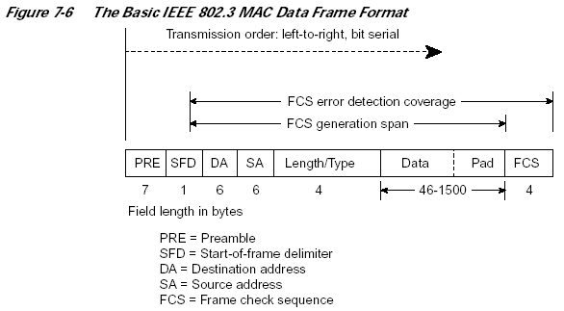

1.8 Frame Transmission
Whenever an end station MAC receives a transmit-frame request with the accompanying address and data information from the LLC sublayer, the MAC begins the transmission sequence by transferring the LLC information into the MAC frame buffer.

- The preamble and start-of-frame delimiter are inserted in the PRE and SOF fields.
- The destination and source addresses are inserted into the address fields.
- The LLC data bytes are counted, and the number of bytes is inserted into the Length/Type field.
- The LLC data bytes are inserted into the Data field. If the number of LLC data bytes is less than 46, a pad is added to bring the Data field length up to 46.
- An FCS value is generated over the DA, SA, Length/Type, and Data fields and is appended to the end of the Data field.

After the frame is assembled, actual frame transmission will depend on whether the MAC is operating in half-duplex or full-duplex mode.

The IEEE 802.3 standard currently requires that all Ethernet MACs support half-duplex operation, in which the MAC can be either transmitting or receiving a frame, but it cannot be doing both simultaneously. Full-duplex operation is an optional MAC capability that allows the MAC to transmit and receive frames simultaneously.

1.9 Inter Frame Gap
After transmission of each frame, a transmitter must wait for a period of 9.6 microseconds (at 10 Mbps) to allow the signal to propagate through the receiver electronics at the destination. This period of time is known as the Inter-Frame Gap (IFG). While every transmitter must wait for this time between sending frames, receivers do not necessarily see a "silent" period of 9.6 microseconds. The way in which repeaters operate is such that they may reduce the IFG between the frames which they regenerate.

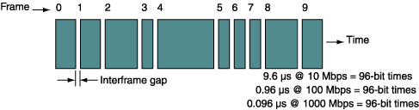
The interframe gap is a self-imposed quiet time appended to the end of every frame. This idle time gives the network media a chance to stabilize, and other network components time to process the frame. Figure 2 shows a sequence of frames separated by the fixed-size interframe gap. For 10-Mbps Ethernet, the interframe gap is 9.6 ms.
This corresponds to 96 bit times (divide 9.6 ýs by 100 ns per bit). Thus, the 576 bits of a minimum-length Ethernet frame are followed by 96 bit times of silence. Dividing 10 Mbps by 672 bits for each frame plus the interframe gap gives a frame rate of 14,880 frames per second (minimum sized frames). Because each frame is followed by 96 bits of silence, there are a total of 14,880 ý 96, or 1,428,480, bits of the 10-Mbps bandwidth (14.28%) lost as a result of the interframe gap. These calculations are shown in Figure 3.

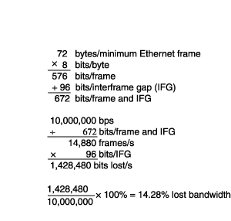
When the frame size is larger, more of the available bandwidth is used (see Table 2). Note that as the frame size increases, the 96 bits of the interframe gap become less significant. The actual frame lengths in a real network will be constantly fluctuating, as shown in Figure 2, so the bandwidth utilization will be constantly changing.

Data size  (bytes) | Frame size  (bits)* | Frames per  second | Total bits lost | Percentage of band width lost
46 | 672 | 14880 | 1428480 | 14.2848
64 | 816 | 12254 | 1176384 | 11.76384
100 | 1104 | 9057 | 869472 | 8.69472
128 | 1328 | 7530 | 722880 | 7.2288
150 | 1504 | 6648 | 638208 | 6.38208
200 | 1904 | 5252 | 504192 | 5.04192
256 | 2352 | 4251 | 408096 | 4.08096
512 | 4400 | 2272 | 218112 | 2.18112
1024 | 8496 | 1177 | 112992 | 1.12992
1500 | 12304 | 812 | 77952 | 0.77952
*Includes 96 bits for interframe gap

1.10 Carrier Sense Multiple Access with Collision Detection (CSMA/CD)

A Shared Medium
The Ethernet network may be used to provide shared access by a group of attached nodes to the physical medium which connects the nodes. These nodes are said to form a Collision Domain. All frames sent on the medium are physically received by all receivers, however the Medium Access Control (MAC) header contains a MAC destination address which ensures only the specified destination actually forwards the received frame (the other computers all discard the frames which are not addressed to them).
Consider a LAN with four computers each with a Network Interface Card (NIC) connected by a common Ethernet cable:
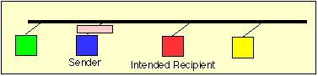
One computer (Blue) uses a NIC to send a frame to the shared medium, which has a destination address corresponding to the source address of the NIC in the red computer.
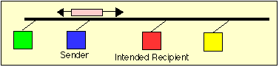

The cable propagates the signal in both directions, so that the signal (eventually) reaches the NICs in all four of the computers. Termination resistors at the ends of the cable absorb the frame energy, preventing reflection of the signal back along the cable.
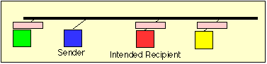

All the NICs receive the frame and each examines it to check its length and checksum. The header destination MAC address is next examined, to see if the frame should be accepted, and forwarded to the network-layer software in the computer.

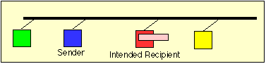

Only the NIC in the red computer recognises the frame destination address as valid, and therefore this NIC alone forwards the contents of the frame to the network layer. The NICs in the other computers discard the unwanted frame.
The shared cable allows any NIC to send whenever it wishes, but if two NICs happen to transmit at the same time, a collision will occur, resulting in the data being corrupted.

Carrier Sense Multiple Access (CSMA)
Ethernet uses a refinement of ALOHA, known as Carrier Sense Multiple Access (CSMA), which improves performance when there is a higher medium utilisation. When a NIC has data to transmit, the NIC first listens to the cable (using a transceiver) to see if a carrier (signal) is being transmitted by another node. This may be achieved by monitoring whether a current is flowing in the cable (each bit corresponds to 18-20 milliAmps (mA)). The individual bits are sent by encoding them with a 10 (or 100 MHz for Fast Ethernet) clock using Manchester encoding. Data is only sent when no carrier is observed (i.e. no current present) and the physical medium is therefore idle. Any NIC which does not need to transmit, listens to see if other NICs have started to transmit information to it.
However, this alone is unable to prevent two NICs transmitting at the same time. If two NICs simultaneously try transmit, then both could see an idle physical medium (i.e. neither will see the other's carrier signal), and both will conclude that no other NIC is currently using the medium. In this case, both will then decide to transmit and a collision will occur. The collision will result in the corruption of the frame being sent, which will subsequently be discarded by the receiver since a corrupted Ethernet frame will (with a very high probability) not have a valid 32-bit MAC CRC at the end.

1.13 Collision Detection (CD)
A second element to the Ethernet access protocol is used to detect when a collision occurs. When there is data waiting to be sent, each transmitting NIC also monitors its own transmission. If it observes a collision (excess current above what it is generating, i.e. > 24 mA for coaxial Ethernet), it stops transmission immediately and instead transmits a 32-bit jam sequence. The purpose of this sequence is to ensure that any other node which may currently be receiving this frame will receive the jam signal in place of the correct 32-bit MAC CRC, this causes the other receivers to discard the frame due to a CRC error.
To ensure that all NICs start to receive a frame before the transmitting NIC has finished sending it, Ethernet defines a minimum frame size (i.e. no frame may have less than 46 bytes of payload). The minimum frame size is related to the distance which the network spans, the type of media being used and the number of repeaters which the signal may have to pass through to reach the furthest part of the LAN. Together these define a value known as the Ethernet Slot Time, corresponding to 512 bit times at 10 Mbps.
When two or more transmitting NICs each detect a corruption of their own data (i.e. a collision), each responds in the same way by transmitting the jam sequence. The following sequence depicts a collision:
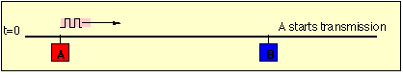
At time t=0, a frame is sent on the idle medium by NIC A.
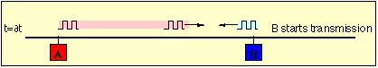
A short time later, NIC B also transmits. (In this case, the medium, as observed by the NIC at B happens to be idle too).
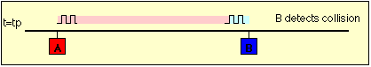

After a period, equal to the propagation delay of the network, the NIC at B detects the other transmission from A, and is aware of a collision, but NIC A has not yet observed that NIC B was also transmitting. B continues to transmit, sending the Ethernet Jam sequence (32 bits).
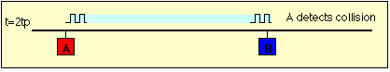

After one complete round trip propagation time (twice the one way propagation delay), both NICs are aware of the collision. B will shortly cease transmission of the Jam Sequence, however A will continue to transmit a complete Jam Sequence. Finally the cable becomes idle.

Retransmission Back-Off
An overview of the transmit procedure is shown below. The transmitter initialises the number of transmissions of the current frame (n) to zero, and starts listening to the cable (using the carrier sense logic (CS) - e.g., by observing the Rx signal at transceiver to see if any bits are being sent). If the cable is not idle, it waits (defers) until the cable is idle. It then waits for a small Inter-Frame Gap (IFG) (e.g., 9.6 microseconds) to allow to time for all receiving nodes to return to prepare themselves for the next transmission.
Transmission then starts with the preamble, followed by the frame data and finally the CRC-32. After this time, the transceiver Tx logic is turned off and the transceiver returns to passively monitoring the cable for other transmissions.
During this process, a transmitter must also continuoulsy monitor the collision detection logic (CD) in the transceiver to detect if a collision ocurs. If it does, the transmitter aborts the transmission (stops sending bits) within a few bit periods, and starts the collision procedure, by sending a Jam Signal to the transceiver Tx logic. It then calculates a retransmission time.
.
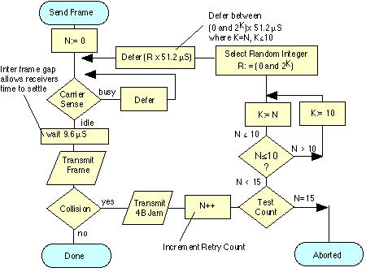

If all NICs attempted to retransmit immediately following a collision, then this would certainly result in another collision. Therefore a procedure is required to ensure that there is only a low probability of simultaneous retransmission. The scheme adopted by Ethernet uses a random back-off period, where each node selects a random number, multiplies this by the slot time (minimum frame period, 51.2 µS) and waits for this random period before attempting retransmission. The small Inter-Frame Gap (IFG) (e.g., 9.6 microseconds) is also added.
On a busy network, a retransmission may still collide with another retransmission (or possibly new frames being sent for the first time by another NIC). The protocol therefore counts the number of retransmission attempts (using a variable N in the above figure) and attempts to retransmit the same frame up to 15 times.
For each retransmission, the transmitter constructs a set of numbers:
{0, 1, 2, 3, 4, 5, ... L} where L is ([2 to the power (K)]-1) and where K=N; K<= 10;
A random value R is picked from this set, and the transmitter waits (defers) for a period
R x (slot time) i.e. R x 51.2 Micro Seconds
For example, after two collisions, N=2, therefore K=2, and the set is {0, 1, 2, 3} giving a one in four chance of collision. This corresponds to a wait selected from {0, 51.2, 102.4, 153.6} micro seconds
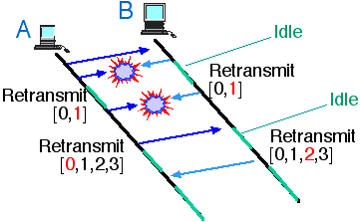
After 3 collisions, N = 3, and the set is {0, 1, 2, 3, 4, 5, 6, 7}, that is a one in eight chance of collision.
But after 4 collisions, N=4, the set becomes {0, 1, 2, 3, 4, 5, 6, 7, 8, 9, 10, 11, 12, 13, 14, 15}, that is a one in 16 chance of collision.
The scaling is performed by multiplication and is known as exponential back-off. This is what lets CSMA/CD scale to large numbers of NICs - even when collisions may occur. The first ten times, the back-off waiting time for the transmitter suffering collision is scaled to a larger value. The algorithm includes a threshold of 1024. The reasoning is that the more attempts that are required, the more greater the number of NICs which are trying to send at the same time, and therefore the longer the period which needs to be deferred. Since a set of numbers {0,1,...,1023} is a large set of numbers, there is very little advantage from further increasing the set size.
Each transmitter also limits the maximum number of retransmissions of a single frame to 16 attempts (N=15). After this number of attempts, the transmitter gives up transmission and discards the frame, logging an error. In practice, a network that is not overloaded should never discard frames in this way.

Late Collisions
In a proper functioning Ethernet network, a NIC may experience collision within the first slot time after it starts transmission. This is the reason why an Ethernet NIC monitors the CD signal during this time and use CSMA/CD. A faulty CD circuit, or misbehaving NIC or transceiver may lead to a late collision (i.e. after one slot time). Most Ethernet NICs therefore continue to monitor the CD signal during the entire transmission. If they observe a late collision, they will normally inform the sender of the error condition.

Performance of CSMA / CD
It is simple to calculate the performance of a CSMA/CD network where only one node attempts to transmit at any time. In this case, the NIC may saturate the medium and near 100% utilisation of the link may be achieved, providing almost 10 Mbps of throughput on a 10 Mbps LAN.
However, when two or more NICs attempt to transmit at the same time, the performance of Ethernet is less predictable. The fall in utilisation and throughput occurs because some bandwidth is wasted by collisions and back-off delays. In practice, a busy shared 10 Mbps Ethernet network will typically supply 2-4 Mbps of throughput to the NICs connected to it.
As the level of utilisation of the network increases, particularly if there are many NICs competing to share the bandwidth, an overload condition may occur. In this case, the throughput of Ethernet LANs reduces very considerably, and much of the capacity is wasted by the CSMA/CD algorithm, and very little is available for sending useful data. This is the reason why a shared Ethernet LAN should not connect more than 1024 computers. Many engineers use a threshold of 40% Utilisation to determine if a LAN is overloaded. A LAN with a higher utilisation will observe a high collision rate, and likely a very variable transmission time (due to back off). Separating the LAN in to two or more collision domains using bridges or switches would likely provide a significant benefit (assuming appropriate positioning of the bridges or switches).
Shared networks may also be constructed using Fast Ethernet, operating at 100 Mbps. Since Fast Ethernet always uses fibre or twisted pair, a hub or switch is always required.

1.15 10-MBPS ETHERNET
The first three widely used Ethernet technologies were 10Base5, 10Base2, and 10BaseT. Figure 7 shows the general 10-Mbps architecture of the data-link and physical layers. Beginning with the media (coax, UTP), you first encounter the medium dependent interface (MDI). The MDI is essentially the connection method used with the media, such as a vampire tap or RJ-45 connector. The physical medium attachment (PMA) provides the functions necessary for transmission, reception, and collision detection. Together, the MDI and PMA make up the medium attachment unit (MAU). The attachment unit interface (AUI) may be a transceiver cable up to 50 m in length, connected via a 15-pin AUI connector. The AUI cable may be used, for example, to connect a thick-wire vampire-tap transceiver to the upstream AUI port of a hub or switch. The physical signaling (PLS) is where Manchester encoding is applied to the bit stream. Table 3 shows the properties of each 10-Mbps technology
10Base5 | 10Base2 | 10BaseT
Media: thick-wire coax (RG-11) | Media: thin-wire coax (RG-58) | Media: category 3, 4, or 5 UTP
Propagation | Propagation | Propagation
velocity: 0.77 c | velocity: 0.65 c | velocity: 0.585 c
Impedance: 50 ohms | Impedance: 50 ohms | Impedance: 100 ohms
Connector: vampire tap | Connector: BNC T | Connector: RJ-45
Segment length: 500 m | Segment length: 185 m | Segment length: 100 m
Maximum nodes/ | Maximum nodes/ | Maximum nodes/
segment: 100 | segment: 30 | segment: 2
Node spacing: 2.5 m | Node spacing: 0.5 m | Topology: star
Topology: bus | Topology: bus
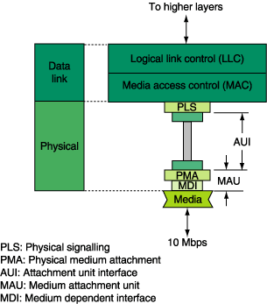
The 2.5-m spacing requirement in the 10Base5 is designed to prevent signal distortions from each station from adding together in phase. The number of nodes allowed on a segment is limited by the electrical properties of the cable. You can see that a different coaxial cable in the 10Base2 affects the allowable cable length as well as the number of nodes/segment. And, the number of nodes/segment is misleading in the 10BaseT because the UTP cable requires a point-to-point connection, typically a NIC to a port on a hub, or a hub-to-hub connection.
All three technologies have some common properties, including:
- 10-Mbps data rate
- Manchester encoding
- maximum of 1024 stations in a single collision domain. Repeaters do not count towards this maximum limit
- maximum of four repeaters in longest path through the network
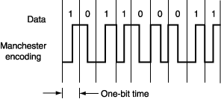
Figure 8 shows an example of how a digital signal is Manchester encoded. A logic zero is encoded as a falling edge in the middle of a bit time. A logic one is encoded as a rising edge. This guarantees an edge during every bit time, making the signal easier to synchronize with and decode. The four-repeater limit chosen to maintain CSMA/CD operation is part of a larger set of restrictions, commonly referred to as the 5-4-3 Rule, which has the following properties:
- five segments in the longest path
- four repeaters in the longest path
- three segments with nodes
- Again, these rules apply to a single collision domain.
Figures 9a and b show two ways of applying the 5-4-3 rule. In Figure 9a, a 10Base5/10Base2 system is illustrated. Three of the five segments contain nodes. The longest path between stations (A and Z) is five segments, with four repeaters in between. Figure 9(b) shows a 10BaseT star network. The A and Z stations are separated by five UTP segments with four hubs in between. Each UTP cable from a station to a hub or from a hub to another hub is considered a segment and may be up to 100 m in length.
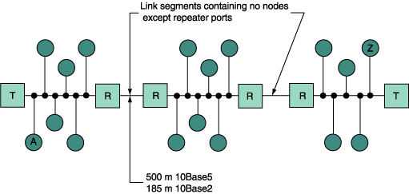

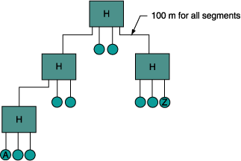

Collisions are detected by a 10BaseT hub whenever two ports are active at the same time. Even though the transmit and receive wire pairs are different and there is no electrical collision (as you see on the coaxial cable), there is an attempt by two stations to use the network simultaneously, which results in a collision. Older equipment is restricted to half-duplex operation, because any station may send or receive but not at the same time. New, auto-negotiating Ethernet transceivers are capable of operating in full-duplex, sending and receiving frames simultaneously.
10BASE F
Originally, the fiber optic inter-repeater link (FOIRL) specification was used to standardize Ethernet communication over fiber. It allowed for a 1000-m fiber between repeaters. Eventually, the demand for fiber to the PC exceeded the FOIRL specifications, and a new set of fiber specifications was designed. This specification, called 10BaseF, contains three categories: 10BaseFL, 10BaseFB, and 10BaseFP. Table 4 shows a list of their properties
10BaseFL | 10BaseFB | 10BaseFP
Fiber link specification | Fiber backbone specification | Fiber passive specification
Station-to-station, station-to-hub, connection | Hub-to-hub connection | Station-to-hub, hub-to-hub and hub-to-hub connection
2000-m segment length | Synchronous operation | Hubs link up to 33 stations
Manchester encoding | 2000-m segment length | 500-m segment length
Replaces FOIRL and works with existing FOIRL hardware Connector: ST

The fiber link specification (10BaseFL) is the most widely used. Figure 10 shows a portion of a 10BaseFL network. Before fiber NICs became available, a 10BaseFL to 10BaseT (or 10Base2) transceiver was used to interface fiber with the PC.
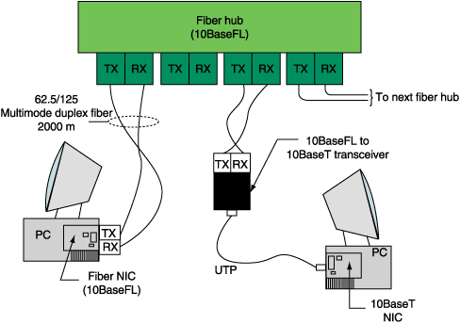

The synchronous operation on the 10BaseFB link is used to reduce the delays normally associated with Ethernet repeaters that cause the interframe gap to shrink as it propagates through multiple repeaters. This allows the segment distance to be extended without compromising the collision detection mechanism.
The fiber passive specification (10BaseFP) allows groups of 10BaseFP computers to be passively connected via a hub, which optically shares signals transmitted from any station. This technology is well suited for low-power environments.
ERRORS IN ETHERNET LANS
When working with Ethernet systems, it is useful to be familiar with some common problems encountered in actual networks.
The maximum transmission unit (MTU) is the maximum frame size allowed on the network. For the Ethernet, the MTU may range from 68 to 1500, with many ISPs setting their lines to an MTU of 576. If the MTU is too small, large frames will be fragmented into two or more smaller frames, contributing to excess use of the bandwidth and increased collisions. Windows users may adjust their MTU by modifying the Registry.
An out-of-control Ethernet transmitter may generate a frame that is longer than 1526 bytes. Other conditions on the network, such as bad terminations or a failing power supply in a hub or switch, may cause distortions that resemble a jabbering device. Repeaters are designed to prohibit retransmission of any frames for a short period of time when jabbering is detected, thus preventing the network from being saturated with meaningless signals.
A runt is any transmitted frame whose length is less than the minimum frame size, even a short frame with a valid FCS.
When all the bits of a frame have been received, it is possible that the last bit received is not the last bit of the final byte in the frame. In other words, the number of bits in the frame is not a multiple of eight. This is called an alignment error. This will most likely cause the FCS to be invalid and the frame will be discarded. Intermittent connections will contribute to this type of error, as will collisions, which terminate with an unknown number of bits transmitted followed by the jam sequence.
Cabling errors typically occur in either the coax or UTP. Problems that can occur in either of these areas are shown in Table 5.
Removing the 50-ohm terminating resistor from the end of a 10Base2 or 10Base5 cable will cause distorted signals to reflect off the end instead of being absorbed by the terminating resistor (because of high-frequency properties of transmission lines). The signal reflections cause repeated collisions, effectively shutting down the entire cable segment.
And finally, the Ethernet exhibits poor performance when its utilization is 60% or more. Excess utilization (including plenty of lost bandwidth because of collisions) is typically the result of too many stations operating in the same collision domain. Replacing hubs with switches or routers will partition the network into multiple collision domains, each containing a smaller number of stations. The improvement in performance will be noticeable.

1.16 Auto-negotiation—An Optional Method for Automatically Configuring Link Operational Modes

The purpose of autonegotiation is to find a way for two NICs that share a UTP link to communicate with each other, regardless of whether they both implemented the same Ethernet version or option set. Autonegotiation is performed totally within the physical layers during link initiation, without any
additional overhead either to the MAC or to higher protocol layers. autonegotiation allows UTP-based NICs to do the following:
- Advertise their Ethernet version and any optional capabilities to the NIC at the other end of the link
- Acknowledge receipt and understanding of the operational modes that both NICs share
- Reject any operational modes that are not shared
- Configure each NIC for highest-level operational mode that both NICs can support
Autonegotiation is specified as an option for 10Base-T, 100Base-TX, and 100Base-T4, but it is required for 100Base-T2 and 1000Base-T implementations. Table 7-4 lists the defined selection priority levels
(highest level = top priority) for UTP-based Ethernet NICs.
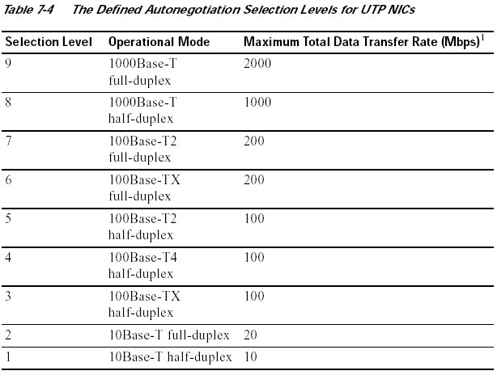

The autonegotiation function in UTP-based NICs uses a modified 10Base-T link integrity pulse sequence in which the NLPs are replaced by bursts of fast link pulses (FLPs), as shown in Figure 7-27. Each FLP burst is an alternating clock/data sequence in which the data bits in the burst identify the operational
modes supported by the transmitting NIC and also provide information used by the auto negotiation handshake mechanism. If the NIC at the other end of the link is a compatible NIC but does not have autonegotiation capability, a parallel detection function still allows it to be recognized. A NIC that fails to respond to FLP bursts and returns only NLPs is treated as a 10Base-T half-duplex NIC.

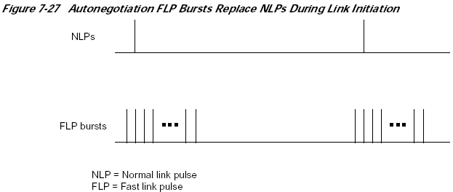

At first glance, it may appear that the autonegotiation process would always select the mode supported by the NIC with the lessor capability, which would be the case if both NICs use the same encoding procedures and link configuration. For example, if both NICs are 100Base-TX but only one supports full-duplex operation, the negotiated operational mode will be half-duplex 100Base-TX. Unfortunately, the different 100Base versions are not compatible with each other at 100 Mbps, and a 100Base-TX full-duplex NIC would autonegotiate with a 100Base-T4 NIC to operate in 10Base-T half-duplex mode.
Autonegotiation in 1000Base-X NICs is similar to autonegotiation in UTP-based systems, except that it currently applies only to compatible 1000Base-X devices and is currently constrained to negotiate only half-duplex or full-duplex operation and flow control direction.

1.17 100 Mbps—Fast Ethernet

Increasing the Ethernet transmission rate by a factor of ten over 10Base-T was not a simple task, and the effort resulted in the development of three separate physical layer standards for 100 Mbps over UTP cable: 100Base-TX and 100Base-T4 in 1995, and 100Base-T2 in 1997. Each was defined with different encoding requirements and a different set of media-dependent sublayers, even though there is some overlap in the link cabling. Table 7-2 compares the physical layer characteristics of 10Base-T to the various 100Base versions.

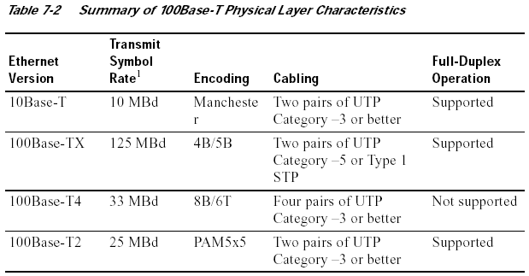
One baud = one transmitted symbol per second, where the transmitted symbol may contain the equivalent value of 1 or more
binary bits.

Although not all three 100-Mbps versions were successful in the marketplace, all three have been discussed in the literature, and all three did impact future designs. As such, all three are important to consider here.

100Base-X

100Base-X was designed to support transmission over either two pairs of Category 5 UTP copper wire or two strands of optical fiber. Although the encoding, decoding, and clock recovery procedures are the same for both media, the signal transmission is different—electrical pulses in copper and light pulses in optical fiber. The signal transceivers that were included as part of the PMA function in the generic logical model of Figure 7-14 were redefined as the separate physical media-dependent (PMD) sublayers shown in Figure 7-16.
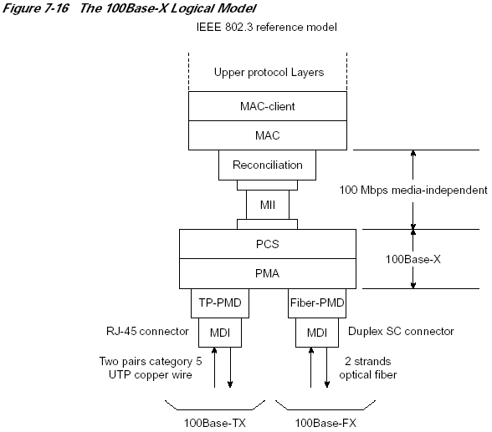

The 100Base-X encoding procedure is based on the earlier FDDI optical fiber physical media-dependent and FDDI/CDDI copper twisted-pair physical media-dependent signaling standards developed by ISO and ANSI. The 100Base-TX physical media-dependent sublayer (TP-PMD) was implemented with CDDI semiconductor transceivers and RJ-45 connectors; the fiber PMD was implemented with FDDI optical transceivers and the Low Cost Fibre Interface Connector (commonly called the duplex SC connector).
The 4B/5B encoding procedure is the same as the encoding procedure used by FDDI, with only minor adaptations to accommodate Ethernet frame control. Each 4-bit data nibble (representing half of a data byte) is mapped into a 5-bit binary code-group that is transmitted bit-serial over the link. The expanded
code space provided by the 32 5-bit code-groups allow separate assignment for the following:

• The 16 possible values in a 4-bit data nibble (16 code-groups).

• Four control code-groups that are transmitted as code-group pairs to indicate the start-of-stream delimiter (SSD) and the end-of-stream delimiter (ESD). Each MAC frame is “encapsulated” to mark both the beginning and end of the frame. The first byte of preamble is replaced with SSD code-group pair that precisely identifies the frame’s code-group boundaries. The ESD code-group pair is appended after the frame’s FCS field.

• A special IDLE code-group that is continuously sent during interframe gaps to maintain continuous synchronization between the NICs at each end of the link. The receipt of IDLE is interpreted to mean that the link is quiet.

• Eleven invalid code-groups that are not intentionally transmitted by a NIC (although one is used by a repeater to propagate receive errors). Receipt of any invalid code-group will cause the incoming frame to be treated as an invalid frame. 100Base-TX transmits and receives on the same link pairs and uses the same pin assignments on the MDI as 10Base-T. 100Base-TX and 100Base-FX both support half-duplex and full-duplex transmission.

100Base-T4

100Base-T4 was developed to allow 10BaseT networks to be upgraded to 100-Mbps operation without requiring existing four-pair Category 3 UTP cables to be replaced with the newer Category 5 cables. Two of the four pairs are configured for half-duplex operation and can support transmission in either direction, but only in one direction at a time. The other two pairs are configured as simplex pairs dedicated to transmission in one direction only. Frame transmission uses both half-duplex pairs, plus the simplex pair that is appropriate for the transmission direction, as shown in Figure 7-18. The simplex pair for the opposite direction provides carrier sense and collision detection. Full-duplex operation cannot be supported on 100Base-T4.

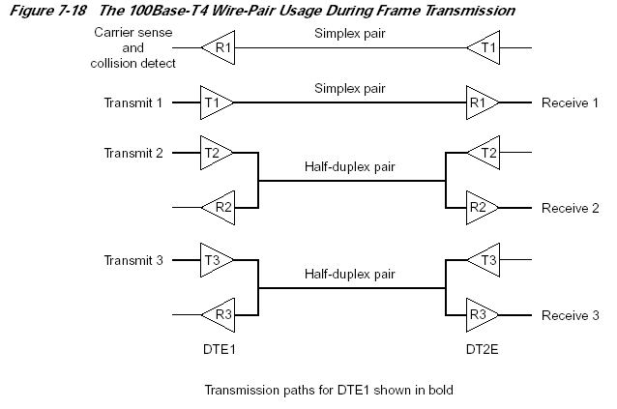

100Base-T4 uses an 8B6T encoding scheme in which each 8-bit binary byte is mapped into a pattern of six ternary (three-level: +1, 0, –1) symbols known as 6T code-groups. Separate 6T code-groups are used for IDLE and for the control code-groups that are necessary for frame transmission. IDLE received on the dedicated receive pair indicates that the link is quiet.
During frame transmission, 6T data code-groups are transmitted in a delayed round-robin sequence over the three transmit wire–pairs, as shown in Figure 7-19. Each frame is encapsulated with start-of-stream and end-of-packet 6T code-groups that mark both the beginning and end of the frame, and the beginning
and end of the 6T code-group stream on each wire pair. Receipt of a non-IDLE code-group over the dedicated receive-pair any time before the collision window expires indicates that a collision has occurred.

100Base-T2

The 100Base-T2 specification was developed as a better alternative for upgrading networks with installed Category 3 cabling than was being provided by 100Base-T4. Two important new goals were defined:

• To provide communication over two pairs of Category 3 or better cable
• To support both half-duplex and full-duplex operation 100Base-T2 uses a different signal transmission procedure than any previous twisted-pair Ethernet
implementations. Instead of using two simplex links to form one full-duplex link, the 100Base-T2 dual-duplex baseband transmission method sends encoded symbols simultaneously in both directions on both wire pairs, as shown in Figure 7-20. The term “TDX<3:2>” indicates the 2 most significant bits in the nibble before encoding and transmission. “RDX<3:2>” indicates the same 2 bits after receipt and decoding.

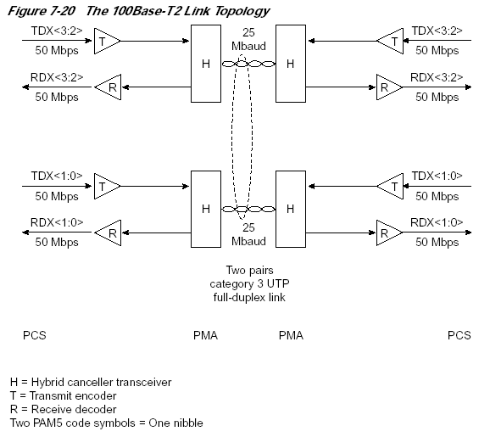

Dual-duplex baseband transmission requires the NICs at each end of the link to be operated in a master/slave loop-timing mode. Which NIC will be master and which will be slave is determined by autonegotiation during link initiation. When the link is operational, synchronization is based on the master NIC’s internal transmit clock. The slave NIC uses the recovered clock for both transmit and receive operations, as shown in Figure 7-21.
Each transmitted frame is encapsulated, and link synchronization is maintained with a continuous stream of IDLE symbols during interframe gaps.
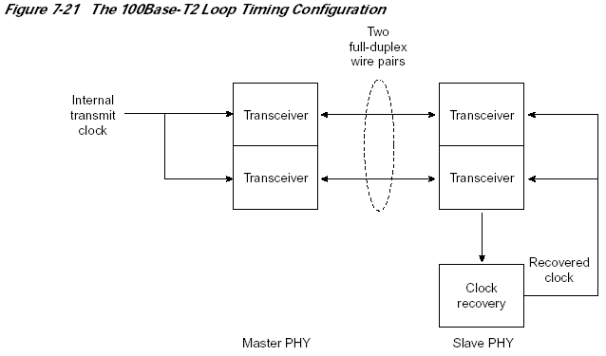

The 100Base-T2 encoding process first scrambles the data frame nibbles to randomize the bit sequence. It then maps the two upper bits and the two lower bits of each nibble into two five-level (+2, +1, 0, –1,–2) pulse amplitude-modulated (PAM5) symbols that are simultaneously transmitted over the two wire pairs (PAM5x5). Different scrambling procedures for master and slave transmissions ensure that the data streams traveling in opposite directions on the same wire pair are uncoordinated. Signal reception is essentially the reverse of signal transmission. Because the signal on each wire pair at the MDI is the sum of the transmitted signal and the received signal, each receiver subtracts the
transmitted symbols from the signal received at the MDI to recover the symbols in the incoming data stream. The incoming symbol pair is then decoded, unscrambled, and reconstituted as a data nibble for transfer to the MAC.

1.18 1000 Mbps—Gigabit Ethernet

The Gigabit Ethernet standards development resulted in two primary specifications: 1000Base-T for UTP copper cable and 1000Base-X STP copper cable, as well as single and multimode optical fiber (see Figure 7-22).

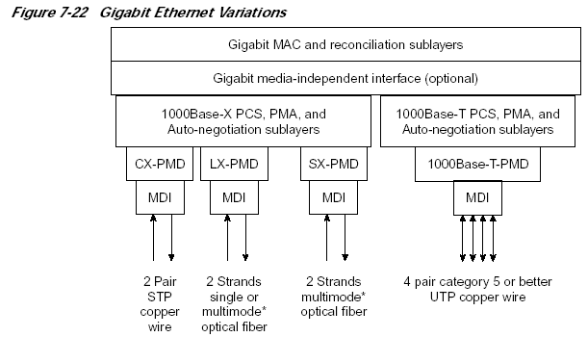

1000Base-T

1000Base-T Ethernet provides full-duplex transmission over four-pair Category 5 or better UTP cable. 1000Base-T is based largely on the findings and design approaches that led to the development of the Fast Ethernet physical layer implementations:

• 100Base-TX proved that binary symbol streams could be successfully transmitted over Category 5 UTP cable at 125 MBd.

• 100Base-T4 provided a basic understanding of the problems related to sending multilevel signals over four wire pairs.

• 100Base-T2 proved that PAM5 encoding, coupled with digital signal processing, could handle both simultaneous two-way data streams and potential crosstalk problems resulting from alien signals on adjacent wire pairs.
1000Base-T scrambles each byte in the MAC frame to randomize the bit sequence before it is encoded using a 4-D, 8-State Trellis Forward Error Correction (FEC) coding in which four PAM5 symbols are sent at the same time over four wire pairs. Four of the five levels in each PAM5 symbol represent 2 bits in the data byte. The fifth level is used for FEC coding, which enhances symbol recovery in the presence of noise and crosstalk. Separate scramblers for the master and slave PHYs create essentially uncorrelated data streams between the two opposite-travelling symbol streams on each wire pair. The1000Base-T link topology is shown in Figure 7-23. The term “TDX<7:6>” indicates the 2 most significant bits in the data byte before encoding and transmission. “RDX<7:6>” indicates the same 2 bits after receipt and decoding.
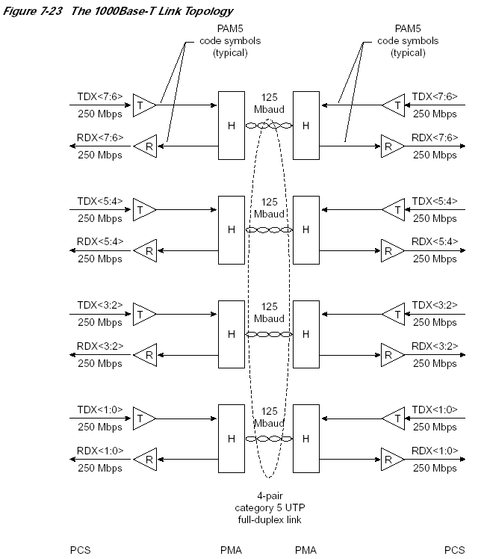

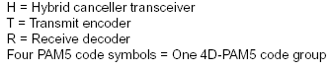

The clock recovery and master/slave loop timing procedures are essentially the same as those used in 100Base-T2 (see Figure 7-24). Which NIC will be master (typically the NIC in a multiport intermediate network node) and which will be slave is determined during autonegotiation.

1000Base-X
All three 1000Base-X versions support full-duplex binary transmission at 1250 Mbps over two strands of optical fiber or two STP copper wire–pairs, as shown in Figure 7-25. Transmission coding is based on the ANSI Fibre Channel 8B/10B encoding scheme. Each 8-bit data byte is mapped into a 10-bit code-group for bit-serial transmission. Like earlier Ethernet versions, each data frame is encapsulated at the physical layer before transmission, and link synchronization is maintained by sending a continuous stream of IDLE code-groups during interframe gaps. All 1000Base-X physical layers support both half-duplex and full-duplex operation.

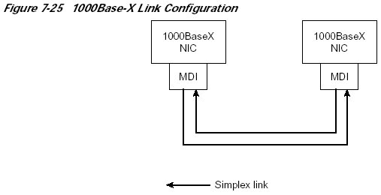
The principal differences among the 1000Base-X versions are the link media and connectors that the particular versions will support and, in the case of optical media, the wavelength of the optical signal (see Table 7-3).

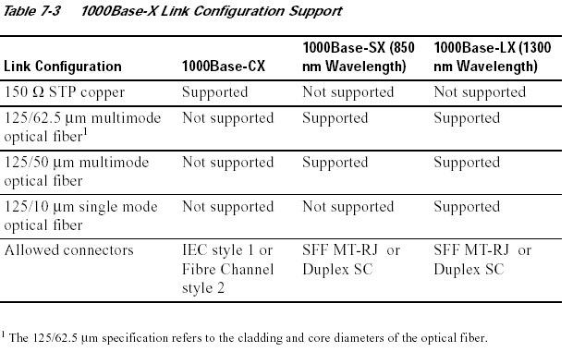
1.19 Network Cabling—Link Crossover Requirements
Link compatibility requires that the transmitters at each end of the link be connected to the receivers at the other end of the link. However, because cable connectors at both ends of the link are keyed the same,the conductors must cross over at some point to ensure that transmitter outputs are always connected to
receiver inputs.Unfortunately, when this requirement first came up in the development of 10Base-T, IEEE 802.3 chose not to make a hard rule as to whether the crossover should be implemented in the cable as shown in Figure 7-26a or whether it should be implemented internally as shown in Figure 7-26b.

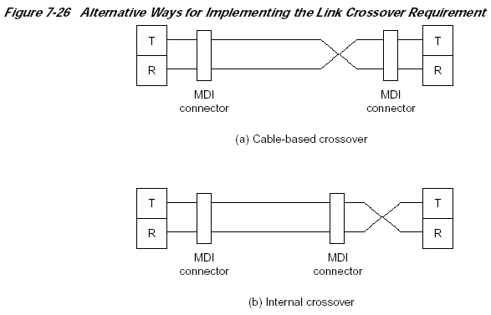

Instead, IEEE 802.3 defined two rules and made two recommendations:

• There must be an odd number of crossovers in all multiconductor links.

• If a PMD is equipped with an internal crossover, its MDI must be clearly labeled with the graphical X symbol.

• Implementation of an internal crossover function is optional.

• When a DTE is connected to a repeater or switch (DCE) port, it is ecommended that the crossover be implemented within the DCE port.

The eventual result was that ports in most DCEs were equipped with PMDs that contained internal crossover circuitry and that DTEs had PMDs without internal crossovers. This led to the following oft-quoted de facto “installation rule”:

• Use a straight-through cable when connecting DTE to DCE. Use a crossover cable when connecting DTE to DTE or DCE to DCE.
Unfortunately, the de facto rule does not apply to all Ethernet versions that have been developed subsequent to 10Base-T. As things now stand, the following is true:
• All fiber-based systems use cables that have the crossover implemented within the cable.
• All 100Base systems using twisted-pair links use the same rules and recommendations as 10Base-T.
• 1000Base-T NICs may implement a selectable internal crossover option that can be negotiated and enabled during autonegotiation. When the selectable crossover option is not implemented, 10Base-T rules and recommendations apply.

1.20 Choosing UTP-Based Components and Media Category
By now, it should be obvious that UTP-based NICs are available for 10-Mbps, 100-Mbps, and 1000-Mbps implementations. The choice is relatively simple for both 10-Mbps and 1000-Mbps operation: 10Base-T and 1000Base-T. From the previous discussions, however, it would not seem to be that simple for 100-Mbps implementations. Although three UTP-based NICs are defined for 100 Mbps, the market has effectively narrowed the choice to just 100Base-TX, which became widely available during the first half of 1995:

• By the time 100Base-T4 products first appeared on the market, 100Base-TX was well entrenched, and development of the full-duplex option, which 100Base-T4 could not support, was well underway.

• The 100Base-T2 standard was not approved until spring 1997, too late to interest the marketplace. As a result, 100Base-T2 products were not even manufactured. Several choices have also been specified for UTP media: Category 3, 4, 5, or 5E. The differences are cable cost and transmission rate capability, both of which increase with the category numbers. However, current transmission rate requirements and cable cost should not be the deciding factors in choosing
which cable category to install. To allow for future transmission rate needs, cables lower than Category 5 should not even be considered, and if gigabit rates are a possible future need, Category 5E should be seriously considered:

• Installation labor costs are essentially constant for all types of UTP four-pair cable.

• Labor costs for upgrading installed cable (removing the existing and installing new) are typically greater than the cost of the original installation.
• UTP cable is backward-compatible. Higher-category cable will support lower-category NICs, but not vice versa.

• The physical life of UTP cable (decades) is much longer than the useable life of the connected equipment.

1.21 WIRELESS ETHERNET (IEEE 803.11)

Wireless LANs form a very small percentage of LANs in operation today, but their use is growing rapidly. Wireless LANs transmit data through the air using radio or infrared transmission rather than through coaxial cable, twisted pair, or fiber optic cable. Until recently, there were few widely accepted standards for wireless LANs and as a result, equipment from different vendors could not be used in the same network. Over the past few years, however, several standards for wireless LANs have emerged, as have new terms: Wireless LAN (WLAN) and Local Area Wireless Network (LAW).

The IEEE 802.11 standard will likely become the dominant standard for WLANs. It is very similar to Ethernet, with a few differences. Most importantly, IEEE 802.11 systems are easily connected into Ethernet LANs and translate between IEEE 802.3 Ethernet and IEEE 802.11 wireless. For this reason, IEEE 802.11 is usually called wireless Ethernet, although its official name is Wireless LAN. IEEE 802.11 is rapidly evolving1.

Media Access Control

Media access control in wireless Ethernet is Carrier Sense Multiple Access with Collision Avoidance (CSMA/CA), which is similar to the CSMA/CD used by traditional Ethernet. With CSMA/CA, computers listen before they transmit and if no one else is transmitting, they transmit. Detecting collisions is more difficult in radio transmission than in transmission over so wireless Ethernet attempts to avoid collisions to a greater extent than traditional Ethernet. CSMA/CA can use two approaches simultaneously to media access control.

Physical Carrier Sense Method

The first media access control method is the physical carrier sense method because it is based on the ability of computers to physically listen before they transmit. Each packet in CSMA/CA is sent using stop and wait ARQ . After the sender transmits one packet, it immediately stops and waits for an ACK from the receiver, before attempting to send another packet. When the receiver of a packet detects the end of the packet in a transmission, it waits a fraction of a second to make sure the sender has really stopped transmitting, and then immediately transmits an ACK (or a NAK). The original sender can then send another packet, stop and wait for an ACK, and so on.

While the sender and receiver are exchanging packets and ACKs, other computers may also want to transmit. So when the sender ends its transmission, why doesn't some other computer begin transmitting before the receiver can transmit an ACK? The answer is that the physical carrier sense method is designed so that the time the receiver waits after the transmission ends before sending an ACK is significantly less than the time a computer must listen to determine no one else is transmitting before initiating a new transmission. Thus the time interval between a transmission and the matching ACK is so short, that no other computer has the opportunity to begin transmitting.

1.21.1 Types of Wireless Ethernet

Two basic types of Wireless Ethernet have been defined: IEEE 803.11b, which is the most common today, and 802.11a which is the high speed alternative.

IEEE 803.11b

IEEE 803.11b in turns has two basic forms. Direct-sequence spread-spectrum (DSSS) systems transmit signals through a wide spectrum of radio frequencies simultaneously (in the 2.4 GHz band). The signal is divided into many different parts and sent on different frequencies simultaneously. Because several radio devices could be operating in these same frequency bands (not just wireless LANs, but also cordless phones), devices add a special code to each bit transmitted that uniquely identifies the signal and enables the intended receiver to identify it.
Frequency-hopping spread-spectrum (FHSS) systems transmit signals through the same wide spectrum of radio frequencies, but use each frequency in turn. A short burst of data is sent on one frequency (usually less than half a second) and then the sender changes to another pseudorandom frequency and broadcasts another burst of data before changing to another frequency, and so on. The transmitter and receiver are synchronized so that they both know which frequencies will be used at which point. This approach minimizes jamming and eavesdropping because it is difficult for an outside listener to know
what frequencies will be used next.
The FHSS version provides speeds of 1 Mbps and 2 Mbps. The DSSS version provides speeds of 1 Mbps, 2 Mbps, 5.5 Mbps, and 11 Mbps. A DSSS 20Mbps version is under development. Because greater distance from the computer to the AP can weaken the signal, making interference from microwave ovens, cordless phones, and baby monitors a major problem, both FSSS and DSSS have the ability to automatically seek changes in speeds. In good conditions at close range, for example, DSSS may provide 11 Mbps, but as the distance increases between the AP and the computer, or if interference increases, the transmission rate may back down to 1 Mbps.
It is important to remember that both versions are shared media implementations, meaning that all devices in the WLAN share the one logical circuit. So if the WLAN has 10 computers, and the speed is reduced to 1 Mbps due to inference, there may be noticeable response time delays. In this example, if we assume a 90% throughput rate (assuming controlled access), this would mean that each computer has about 90Kbps.

IEEE 803.11a
As we write this, the IEEE 803.11a standard has not been completely defined, but it should be by the time you read this. IEEE 803.11a is expected to operate in the 5 GHz range, meaning that it is capable of much higher transmission speeds but also will likely be more susceptible to interference. The initial standard will likely provide a raw data rate of 54Mbps, but will probably only average 20 Mbps in practice.

Infrared Wireless LANs

In general, infrared wireless LANs are less flexible than the radio-based IEEE 802.11 WLANs because most require a direct line of sight between the transmitters and receivers in the same manner as your TV remote control. Transmitters and receivers are usually mounted in fixed positions to ensure the line of sight, so most infrared LANs are wireless only between the hubs. The NICs inside the computers are connected via traditional wires to a network hub which contains the transmitter . The hubs use wireless transmission to communicate from hub to hub.

The primary advantage of a wireless LAN is the reduction in wiring. Infrared-based LANs are sometimes used for communication between buildings where installing underground cable would be expensive. In an old building where wiring is difficult and costs are extremely high, wireless LANs offer a low cost alternative by enabling communication without the installation of cables. Most infrared wireless systems provide 1-4 Mbps, but some provide 100 Mbps or more.

A new version of infrared, called diffuse infrared, operates without a direct line of sight by bouncing infrared light around a room. Most diffuse infrared systems have extremely short ranges (usually only 50-75 feet) and will only operate in the same room because the light cannot travel through walls.

Bluetooth

Bluetooth is strikingly different from the wireless LAN technologies discussed above. Its goal is to provide seamless networking of devices in a very small area (up to 30 feet, soon to increase to about 300 feet). Bluetooth is an unofficial standard but may soon be standardized as IEEE 802.15.

Bluetooth devices are small (about 1/3 of an inch square) and cheap (currently priced at about $30 but expected to quickly to drop to $4 or even lower. A Bluetooth network is called a piconet and consists of no more than 8 devices, but can be linked to other piconets to form a larger network. A typical application might be to connect a mouse to a computer, to connect a telephone headset to a base unit (up to 3 digital voice circuits can be in use simultaneously) , or to link your Palm handheld computer with your car so that your door unlocks and automatically opens as you approach.

Bluetooth provides a 1 Mbps shared circuit, but its data link protocol is inefficient, so it provides only a 780 Kbps throughput. It uses FHSS in the same crowded 2.4 Ghz range used by IEEE 803.11b, so interference with 803.11b devices can significantly reduce throughput in both the Bluetooth and 802.11b networks. It uses controlled access media access control, with one device, called a master, polling the other devices, called slaves.

